**Project management**

**Sprint 1**

**Team 10 Members:**

**Yehudit Mandelboim 313526675**

**Sitara Alayev 321967556**

**Sharon Yaroshetsky 207948381**

**Anthony Eitan Fleysher 203192331**

**Sprint Summary:**

In the first sprint we've built a skeleton structure for our website, it has basic features like a nav bar, log-in page (with no database connection as of yet) and other stub buttons like Services, About etc.

Furthermore, we've built a custom page for not found pages i.e., 404 page.

The log-in page has a syntax authentication Email & Password fields.

* Password length has to be longer than 7 characters.

The project has the following directory structure:

* The *src* directory consists of our development files which are separated to the following directories:
  + Views – our Embedded Java Script files.
  + CSS – styling files of the project.
  + Script – for now, consists only 1 file *scripts.js* with the nav-bar & syntax authentication code.
* The *test* folder will include all the tests we will make for the project.

Currently we have no back-end tests to perform.

* The *doc* folder will include this file and any other documentations we will be asked to make (like functional & non-functional requirements)
* Our linter, *ESlint*, has it own default configuration + custom rules we’ve added during development, just checkout the file from line 28 to see those rules.
* Other configuration files/folders like *package.json, package-lock.json, circleCI* (CI configuration, runs *ESlint & tests*).

**Website screenshots:**

**Home page:**

**Login page:**

**Login page with syntax authentication example:**

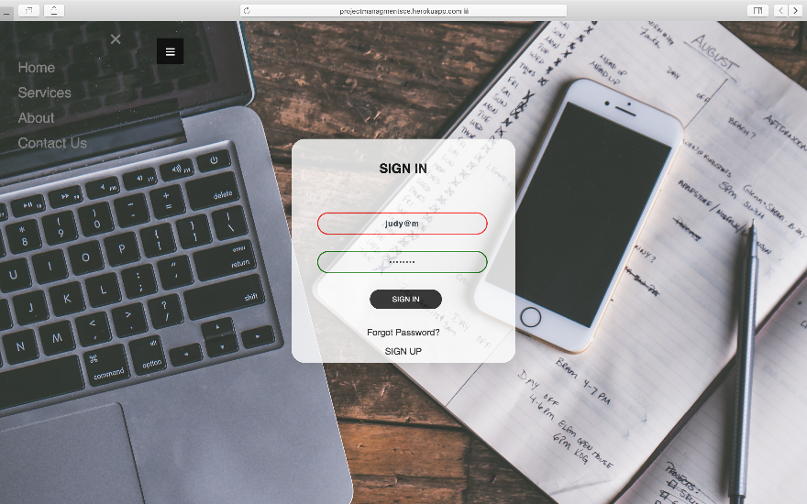

**Setup and run:**

1. Clone our repository by using:
   * HTTP - git clone https://github.com/kartowka/ProjectManagement.git or with
   * SSH - git clone git@github.com:kartowka/ProjectManagement.git
2. Run *npm install* in the root directory of the project.
3. Run *npm run dev*.
4. Ctrl + left click the given local address for our website.
   * Optionally, you can run our heroku [deployed](https://projectmanagmentsce.herokuapp.com/) version of the project.

**CI/CD pipeline:**

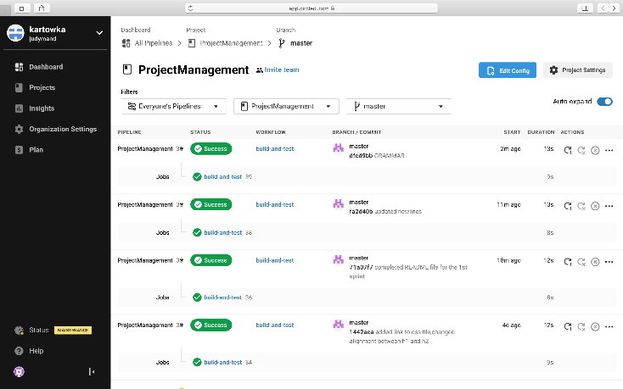Continuous Integration:

Continuous Development:

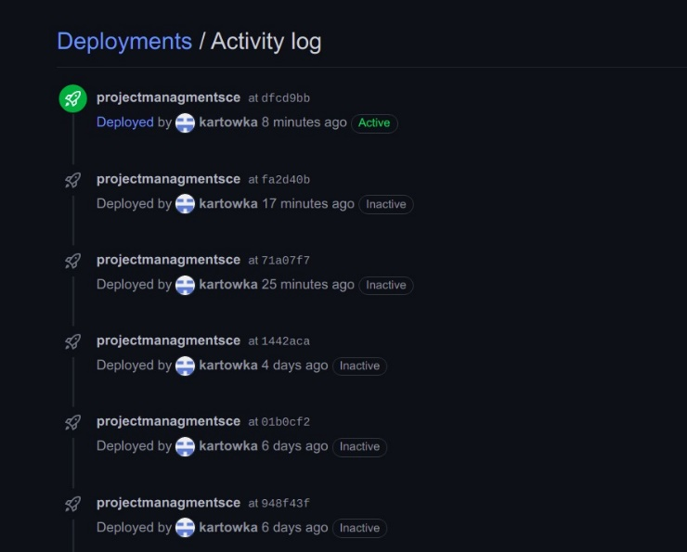

**Links:  
Integration**

* [CircleCI](https://circleci.com/)

**Deployment**

* [Heroku](https://www.heroku.com/)